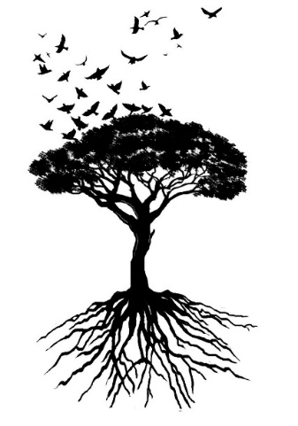

**SBI 3U Biodiversity Unit: Big Ideas**

1. All living things can be classified according to their anatomical and physiological characteristics.
2. Human activities affect the diversity of living things in ecosystems.
3. Diversity is represented by six different Kingdoms.

**Biodiversity Learning Targets**

* #1. I can explain why biodiversity is important to maintaining a healthy, viable ecosystem.
* #2. I can analyze the impact of human intervention and natural, environmental change to the biodiversity of an ecosystem.
* #3. I can use proper sampling techniques to collect various organisms and classify them according to the principles of taxonomy.
* #4. I can classify, compare and/or draw biological diagrams representing organisms from each of the kingdoms, according to their unifying and distinguishing, anatomical and physiological characteristics.
* #5. I can compare and contrast the structure and function of different types of prokaryotes from Kingdom Eubacteria and Kingdom Archaea.
* #6. I can compare and contrast the structure and function of different types of viruses.
* #7. I can compare and contrast the structure and function of different types of eukaryotes from Kingdoms Protists, Fungi, Plants and Animals.

**Long Answer Response (Unit Test)**:

“The classification of organisms occurs according to their anatomical and physiological characteristics.”