Circulatory System – Blood Vessels

Learning Target #2b). I can describe how the structures and functions of specific systems in the body work together to maintain homeostasis in the circulatory system.

Blood Vessels – There are 3 types:

1)

2)

3)

Blood Flows in the Following Path. Please indicate on this diagram where nutrients/oxygen is taken into the body and waste is picked up to be removed from the body.



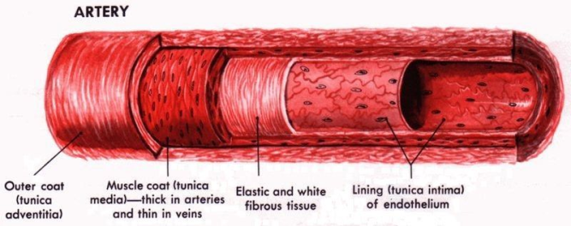

Characteristics of Arteries

What is a pulse?

List three common locations of where a pulse can be found on the body.

Characteristics of Veins

What are varicose veins and how do they develop?

Characteristics of Capillaries

Blood Pressure

Indicate where in the system blood pressure is the highest and where in the system it reaches its lowest point.

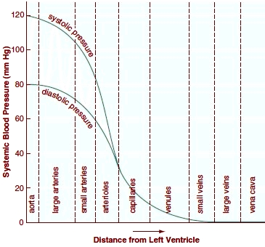

Compare diastolic and systolic pressure.

Practice Questions

1. Describe the illness of hypertension. Why is it called the “silent killer”.
2. When a person exercises, one of the physiological responses is an increase in blood flow. In terms of the circulatory system, describe what’s happening.