Cell Types and Domains

Learning Target: #4. I can classify, compare and/or draw biological diagrams representing organisms from each of the kingdoms, according to their unifying and distinguishing, anatomical and physiological characteristics.

Lesson Question: What are the two types of cells that make up all life on Earth?

- Prokaryotes
- A smaller, simple type of cell the lacks a nucleus and any other organelles bound by a membrane
- Means “before the nucleus”
- Considered to be the most ancient cell type
- Most common examples include bacteria
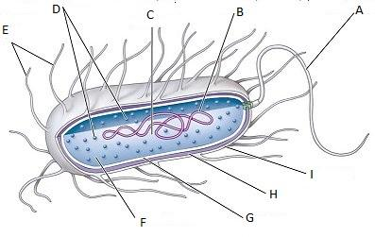

- Eukaryotes
- A larger, complex type of cell that contains membrane-bound organelles including the nucleus
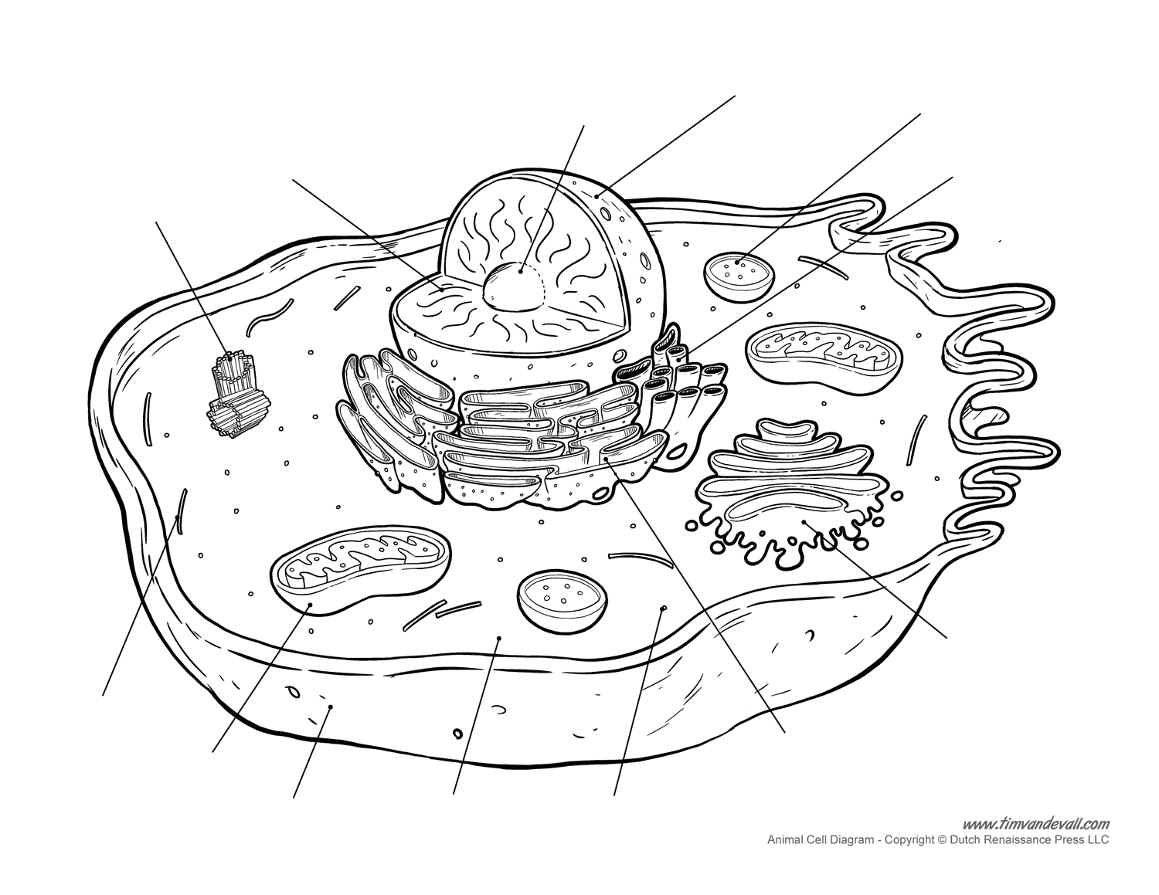
- Means “true nucleus”
- Size range can exceed a 1000 um
- Demonstrated great diversity in structure and function
- Includes plants, animals, ect.

Domains and Kingdoms
- The highest and broadest taxon
- Only 3 domains
  - Based on the two cell types
  - Based on phylogenetic relationships revealed by genetic evidence
1.Domain Eukarya
- Consists of eukaryotes
- Both unicellular and multicellular organisms exist
- Includes following Kingdoms: Animals, Plants, Fungi, Protista
2.Domain Eubacteria (Bacteria)
- Consists of prokaryotes
- Unicellular organisms ONLY
- Includes Kingdom Eubacteria
3.Domain Archaea
- Consists of prokaryotes
- Unicellular organisms only
- Includes Kingdom Archaea

6 Kingdoms:

Lesson Summary:
- Biologists classify living things using a system of six kingdoms and three domains
- System is based on phylogenetic relationships
- Two cell types (prokaryotes and eukaryotes) make up the basis of all life on Earth

Lesson Review

Read Section 1.4 (pg 26-29)

Pg 29. Questions 1, 2, 5

