The Human Heart
- Label the following diagram we discuss in class.
- Colour the “oxygenated” chambers red and colour the “de-oxygenated” chambers blue.
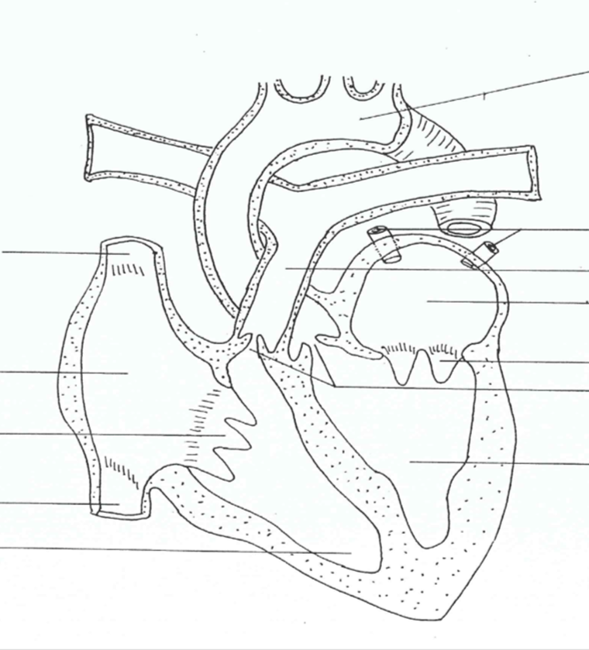
- Starting with the superior and inferior vena cava, list in order the path and direction blood takes as it flows through the heart. Support this blood flow with arrows in appropriate directions.

