Human Karyotypes
Purpose
To examine and prepare human karyotype charts

Background
The term karyotype refers to a photograph of the chromosomes of a cell at a time when each still consists of two ‘sister’ chromatids attached to each other at their centromeres.
To prepare a karyotype chart, scissors are used to cut out each chromosome from an enlarged photo of the karyotype. Chromosome pairs are identified, and then arranged in chart form (figure 1). Chromosomes are arranged by size, banding pattern and centromere location.
Numbers or letters have been assigned to specific chromosome pairs. Analysis of karyotype charts is helpful in the study of chromosome abnormalities.

Figure 1: A Human Karyotype (left) and Karyotype Chart (right)
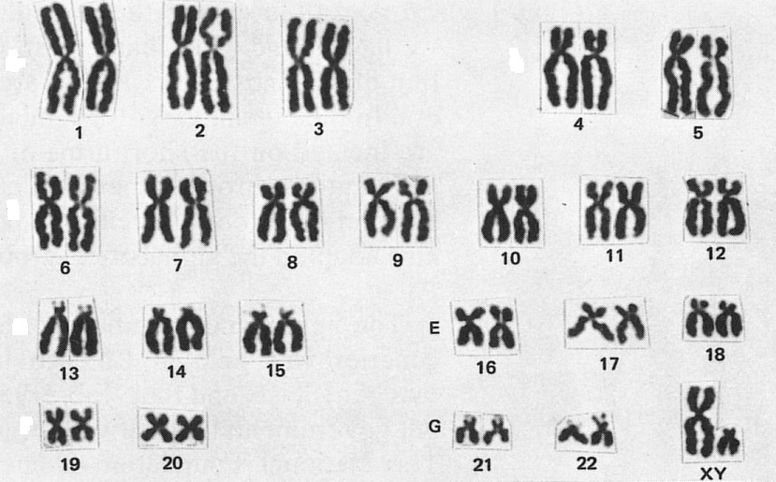
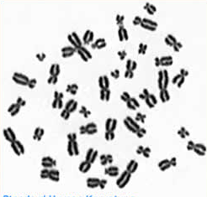

Special staining techniques can reveal light and dark regions (bands) on the chromosomes. By matching the bands, it is now quite easy to identify specific chromosomes and prepare a karyotype chart (figure 2).
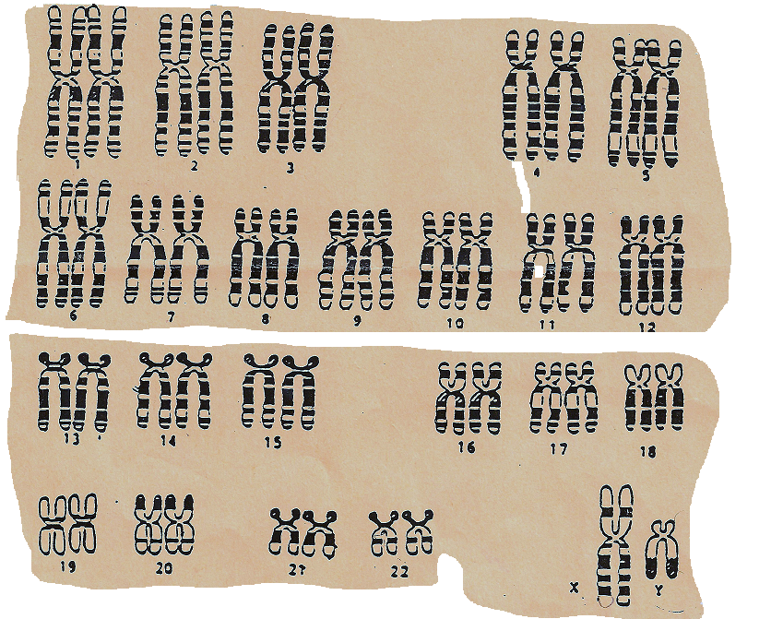
Figure 2: A Human Karyotype Chart Using Chromosomes With Simulated Banding

Part 1: The structure of a human karyotype chart

- Carefully examine the human karyotype illustrated in figure 2 (previous page)
- How many rows of chromosomes are in a karyotype chart?
- Record the total number of chromosomes in the individual.
- How many chromosome pairs are shown?
- What characteristic is used to give a chromosome pair a number?
- Which pair is not given a number? Why?
- What is the sex of this individual? Explain.
- What point in the life of a cell would be best for photographing a karyotype?

Part 2: Chromosome Abnormalities
- Two type of chromosome abnormalities are easily seen in a karyotype:
- Abnormal number
- Major defects in structure

The major characteristics of some well documented abnormalities in humans are outlined in Table 1.

Table 1: Some Chromosome Abnormalities in Humans

Chromosome Abnormality | Syndrome  (condition) | Effects on Individual  (Variable)
XO | Turner’s Syndrome | - Sterile female  - Underdeveloped female characteristics  - Short stature  - Sometimes below normal intelligence
XXY | Klinefelter’s Syndrome | - Sterile male  - Abnormal male characteristics  - Abnormally long arms and legs  - Below normal intelligence
Trisomy #21 | Down’s Syndrome | - Low mental ability  - Short arms and legs  - Internal defects  - Distinct facial features
Trisomy #18 | Edward’s Syndrome | - Severe abnormalities  - Life expectancy about 10 weeks
Trisomy #13 | Patan’s Sydrome | - Severe defects including small, non-disfunctioning eyes  - Survive only a few weeks after birth
Defective #5  (part of chromosome missing) | Cri du Chat | - Severe defects, both physical and mental  - Sound, when crying, similar to cats’ meow

Examine Table 1 carefully:
- What is the chromosome count in an individual with Turner’s Syndrome? Down’s Syndrome?

- How do these numbers compare to the normal chromosome count?

Part 3: Preparing a Human Karyotype Chart
- Obtain a copy of a karyotype photograph(s) from your teacher. The chromosomes are outline drawings of original banded structures, highly enlarged.
- Carefully cut out each chromosome then match the pairs.
- Using figure 2 as a model, prepare a karyotype chart by taping the chromosomes to a sheet of unlined/blank paper.
- Number each autosomal pair and label the sex chromosomes by letter.
- Refer to the karyotype you constructed and table 1 to answer the following questions:

- What sex is this individual? Explain

- What is the total chromosome count in the individual? Is this the expected number?

- How would a medical geneticist describe this individual?

Part 4: Questions for Application and Research
- Why is karyotyping a major activity in medical genetics? How is it used?

- Down’s syndrome is caused by the process of non-disjunction during meiosis.
  - Could an individual with Down’s syndrome ever have normal children? Explain.

  - What are the chances that a 40 year old pregnant woman could have a child with Down’s syndrome?

