SBI3U - Identifying Species & Dichotomous Keys

Learning Target: #3. I can use proper sampling techniques to collect various organisms and classify them according to the principles of taxonomy.

Lesson Question: Why are donkeys and horses considered different species?

NOVA- Online interactive
http://www.pbs.org/wgbh/nova/nature/classifying-life.html

Taxon | Bear | Orchid | Sea Cucumber
Kingdom
Phylum
Class
Order
Family
Genus
Species

Species: A group of organisms that can interbreed in nature and produce fertile offspring
1. Morphological Species Concept
•Focuses on morphology of an object
Morphology: structure or form of an object
•Relies on comparing measurements and descriptions of similar organisms
•Takes into account that species change over time and that they have variation

2. Biological Species Concept
•Focuses on similar characteristics and the ability of organisms to interbreed in nature and produce viable, fertile offspring

3. Pylogenetic Species Concept
•Focuses on the evolutionary relationships among organisms
Phylogeny: evolutionary history of an organism
Evolution: the scientific theory that describes changes in species over time and their shared ancestry
•A species is a cluster of organisms that is distinct from other clusters and shows a pattern of relationships among organisms
•A diagram that shows these relationships is called a phylogenetic tree
- Node (or clade) represents a common ancestor

Dichotomous Keys
What is a dichotomous key and how is it used?
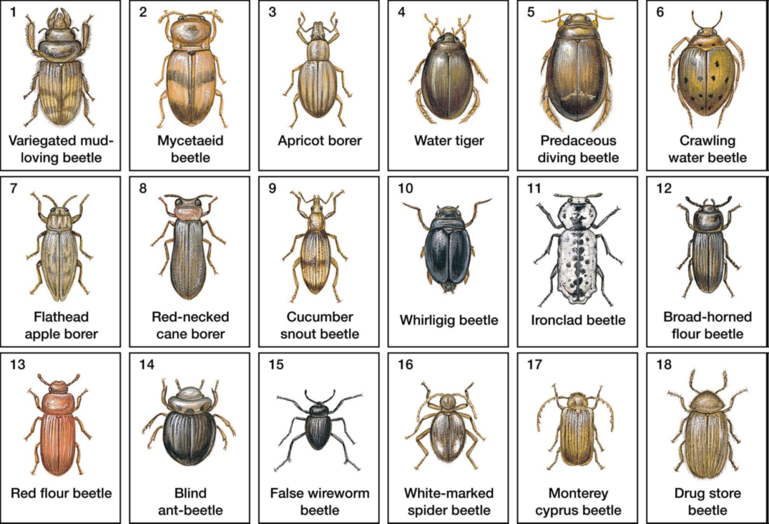

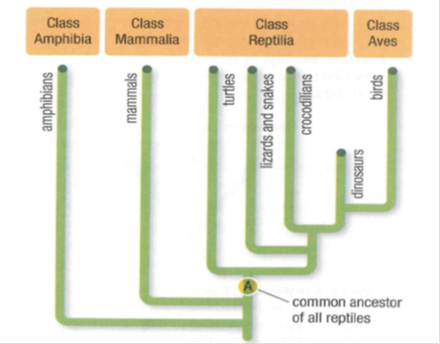
Develop a dichotomous key for identifying beetles.

Lesson Review
Read pages 21-25
1) What is the International Barcode of Life Project?

2) Pg 25. Question # 10 A-D

3) On the following phylogenetic tree which two classes are the most closely related of the living groups?
a. Amphibians and mammals
b. Turtles and crocodiles
c. Birds and crocodiles
d. Birds and mammals

