SBI3U Fetal Pig Dissection – Lab Manual Name & Date: _________________

Part 1: Safety
- Do not wear contact lenses. The chemical preservative (formalin) can get behind the contact lens can cause eye damage
- Safety gloves and goggles must be worn at all times. Do not allow any of the fluids from the pig to contact the skin or eyes.
- Do not pour any liquids down the sink. All of the liquid preservative (formalin) must be poured back in the bin for proper disposal
- Pigs and/or dissected body parts are NOT to be removed from the classroom at any time
- No horseplay or fooling around of any kind is permitted
- Absolutely no food, water, or gum is permitted during the lab.
- Immediately report any injuries or accidents to the teacher, no matter how minor.

Part 1 Continued: Proper Clean-Up and Disposal
- Do not remove your goggles or gloves until everything has been cleaned up, disinfected, and wiped clean. Even if you feel warm, please do not remove any safety equipment until the end of the clean-up.
- Please place your dissected body parts back into the bucket at the front of the room. Do not throw anything in the garbage, and do not put anything down the drain.
- When you are finished the dissection, please spray your station with disinfectant spray (keep your goggles and gloves ON while doing this). Make sure you spray the tray, the scissors, the probes, tweezers, the desk, and any other solid area you may have contacted. Thoroughly wipe the disinfectant spray using the provided cloths. Place the used cloths in the garbage when finished.
- Once cleaned, and wiped, place all of your dissection instruments back in the correct area of the cart. Stack your dissection trays neatly on the cart.
- Remove your gloves, goggles, and wash your hands with soap before going to your next class.

Failure to follow proper safety, clean-up, and disposal instructions will result in a loss of marks.

Part 2: Animals used for scientific research and dissection help us to understand our own bodies and how they function in health and disease. The fetal pig will be used as a representative mammal. As a fetus, the pig receives nutrients and oxygen from its mother through the umbilical cord. Read the safety and dissection directions carefully. Dissection will help you to get a 3-dimensional picture of how all the systems fit together. You've seen separate diagrams of many of the major systems. Now you'll get to see how they are arranged spatially. You'll also get a better idea of the texture of many organs that make up the pig's system.

This lab will be broken up into the following parts:
- External Anatomy
- Oral Cavity & Digestive System
- Circulatory System
- Respiratory System

Materials:

- preserved fetal pig, dissecting pan, scissors, scalpel, forceps, probe, and twine

External Anatomy

The gestation period for a pig is 112-115 days. The chart below compares the relative sizes of a fetal pig at different times during gestation or the time of development inside the uterus. (mm = millimeters)
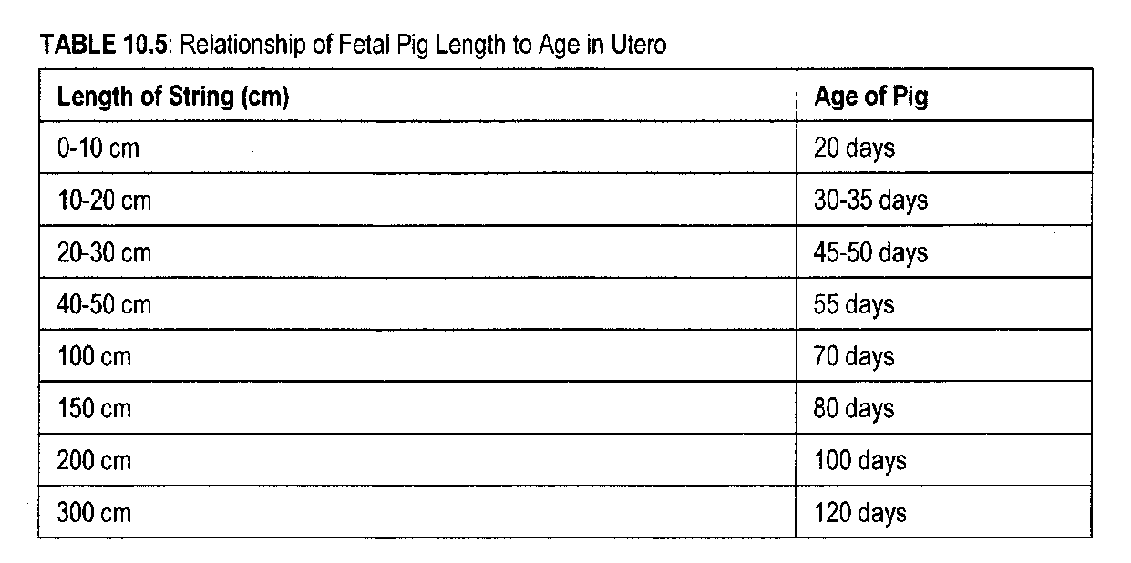

- Using a piece of twine (string) and a ruler, measure the length of your pig from snout to tail. Decode the age of the fetus by using the chart above: ____________________

Generally speaking, orders of mammals are recognized rather easily by their external appearance. These external features which separate mammals into orders are such traits as the number of digits (toes or fingers) on the feet, method of walking or other locomotion and characteristics of the teeth.

- Look at your pig’s feet, and count how many toes it has: _______________.

Mammals have two unique external characteristics which distinguish them from all other vertebrates: (1) all mammals have hair at some time during their development, and (2) all female mammals possess mammary glands with external openings for nourishing the young. Your fetal pig probably does not have a lot of hair due to the fact that it is not fully developed yet. However, at maturity most pigs do have some strands of hair on their
body.

- Examine your pig’s body carefully. Does it have any hair on its body? (Yes or No) _____
- Does it have eyelashes? ______

How can we determine the sex of your pig? The penis and urethral opening of the male pig are located just behind the umbilical cord. If your pig is young, the scrotal sacs may still be empty, as the testes descend just before birth. If you have a more mature male, the testes
will have descended to fill the scrotum.

If the pig is female, you will notice a small projection just below her tail. The opening just below her tail is the anus; the one below the small projection is the vaginal orifice.
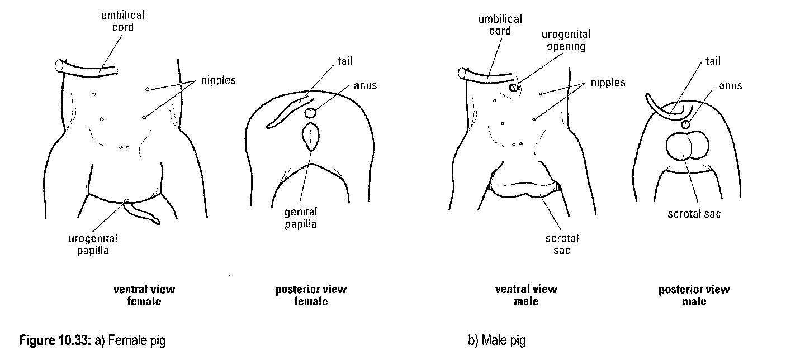
- Is your fetal pig a male or a female? _____________________________

- What evidence from the pig supports your hypothesis? ____________________________

BEFORE YOU DISSECT: Most cuts can be done with scissors. Only use the scalpel when instructed to do so. Ensure that your fetal pig is secured to the dissection pan. Use the dissection pins and twine to tie down your specimen. Dissection is an art and you must be as careful as possible when doing this lab. Do NOT remove any organs or cut any part of the pig unless instructed to do so (refer to this dissection guide). Do NOT walk around the room with sharp objects.

Oral Cavity & Digestive System

1) Using scissors, cut deeply into both corners of the mouth. This may be difficult as you will be cutting through tissue and bone.

2) Open the mouth. Examine the oral cavity, including the tongue and teeth.

3) Far back in the mouth is the pharynx. Locate and identify:
- The Pharynx
- The Tongue
- The Teeth

4) Begin opening the abdominal cavity by cutting carefully using the pattern in figure 10.34. When you reach the thoracic (chest) region, you will encounter bone. You need to cut through the bone to expose the underlying organs. Pull back the two flaps of skin so that you can observe the organs.

5) The large brownish organ is the liver. Using a probe, lift the liver to expose the gall bladder.

6) Locate the esophagus and stomach. The stomach is located under the liver on the upper left side of the abdominal cavity. Using a scalpel, make a cut in the stomach (cut longitudinally).

7) The stomach leads to the small intestine & large intestine. Locate both intestines and differentiate between the two. Follow the large intestine (colon) to the rectum. Using your probe, push on the rectum.
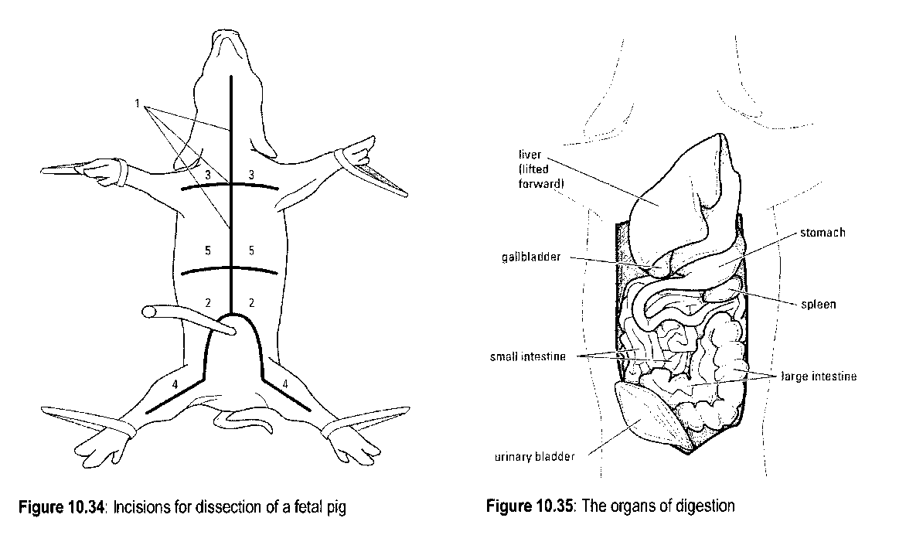
8) Locate the pancreas (white granular organ below the stomach).

9) Review the Digestive Organs. Check off each organ as you have located it:
- Esophagus
- Stomach (what was inside the stomach?)
- Liver
- Gall Bladder
- Small Intestine
- Large Intestine (what happened when pushing on the rectum?)
- Pancreas

Part 3: Circulatory System
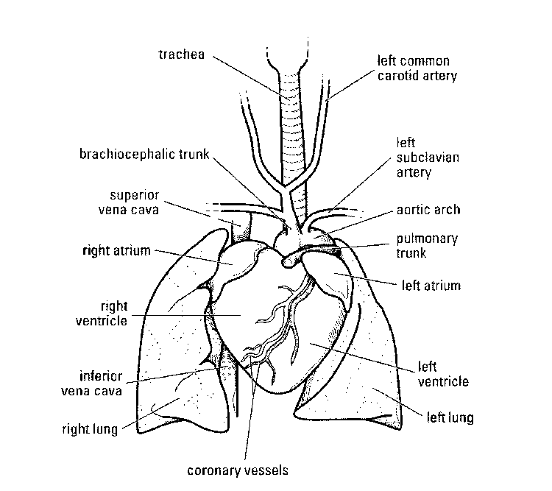
10) The circulatory system of the pig consists of the heart, arteries, veins and capillaries. Refer to figure 3 below. Pulmonary circulation supplies the lungs with blood, systemic circulation supplies blood to the rest of the body except the lungs. Cut through the sternum to open the thoracic cavity. Locate the heart.

11) Covering the heart is a thin, tough membrane called the pericardium. The heart is composed of four chambers.

12) The pig may have been injected with coloured latex which makes it very easy to locate the veins (blue) and arteries (red). See if you can tell the difference between your pig’s veins and arteries.

13) Identify the pulmonary artery (near right ventricle) and aorta (passes along dorsal side of thoracic and abdominal wall).

14) Carefully remove the heart from the pig.

Part 4: Respiratory System

15) The respiratory system is responsible for exchange of gases. The pig must take in oxygen to burn food and must rid itself of carbon dioxide. Air enters through the external nares. Air is drawn into the nasopharynx (nose chambers) where sensory nerve cells detect smell. Here is also where the glottis may be found (opening of the trachea).

16) Locate the trachea (tube that extends from the neck to the chest). It is white and lined with cartilage. The enlarged part of the trachea contains the larynx (voice box) which contains the vocal cords).

17) The trachea splits into the bronchi and bronchioles, which lead to the lungs (located on either side of the heart). Locate the thin muscular diaphragm just above the liver.

