SBI 3U - The Respiratory System
Learning Target #2c: I can describe how the structures and functions of specific systems in the body work together to maintain homeostasis in the respiratory system.

Why We Breathe
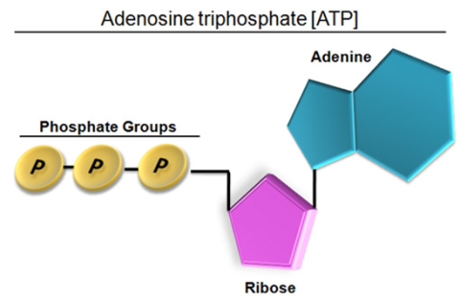
Cellular Respiration: the chemical processes in the mitochondria of the cell of creating energy (ATP) by taking in oxygen and glucose, cleaving or breaking down this glucose and releasing chemical dioxide and water.

We know that our body works best in an environment of 21% oxygen, 78% nitrogen and 0.03% carbon dioxide.
Cellular Respiration is roughly 36% efficient for every 1 molecule of glucose. The rest is released as thermal energy.

Function of the Respiratory System:
- 2) 3)

Structures of the Respiratory System
Name | Structure | Function
Nasal Passages

Pharynx

Epiglottis

Trachea

Bronchi/Bronchioles

Alveoli
Diaphragm

Pleural Membrane

Intercostal Muscles

Gas Exchange v. Ventilation
Breathing is autonomic based on feedback mechanisms from oxygen and carbon dioxide sensors in the brain – you don’t have to think about it! Homeostasis!
Gas Exchange:

Ventilation:

SBI3U – The Respiratory System continued…..

Mechanics of Breathing Volume v. Pressure
Inhaling and Exhaling

Structure & Process | Inhaling | Exhaling
Intercostal Muscles & Diaphram
Chest Cavity
Air Movement

**Diffusion: Air exchange happens through passive transport known as diffusion. This type of transport does not require energy, molecules move randomly and molecules move from an area of __________ concentration to _________ concentration.

Disorders of the Respiratory System
Learning Target #4: I can defend how various illnesses/disorders can affect homeostasis in the body and how they can be prevented.

 | General Definition of Disorder | Causes of Disorder | Symptoms of Disorder | Available Treatments
Asthma

COPD – Emphysema
COPD - Bronchitis
Influenza (Swine Flu)
Tuberculosis
Pneumonia

Cystic Fibrosis

