SBI3U – Genetics - Mitosis v. Meiosis
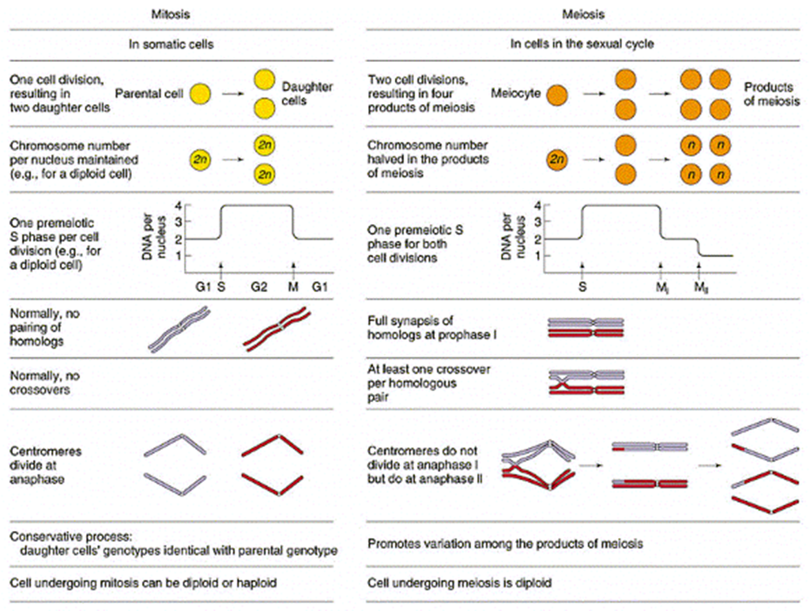
Study the diagram carefully below. Highlight/circle the differences between both cell division processes. Detail each difference below.

