SBI3U - Sex-Linked Inheritance

- How many pairs of chromosomes do humans have?

Autosomal Inheritance:

- Males and females affected ___________ since there’s no difference between autosomes of males and females

Sex-Linked Inheritance:

RECALL:
- Females:
- Males:
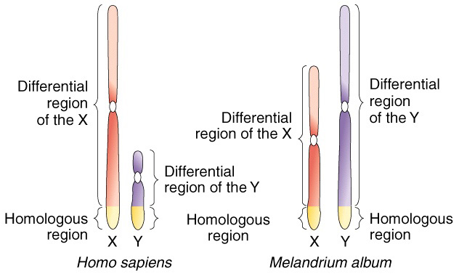

X and Y Chromosomes

X-Linked Disorders:

- A recessive allele for a disorder located on the X chromosome is more likely to express itself in males than females WHY??

MALES:

FEMALES:

Y-Linked Disorders:

- Fewer Y-linked disorders than X-linked because Y chromosome is small and does not carry as much genetic information as X chromosome

Recessive Lethal Disorders: A trait that, when both recessive alleles are present (homozygous recessive), result in death or severe malformation of the offspring E.g. Sickle Cell Anemia & Cystic Fibrosis

Sample Sex-Linked Problems

- Hemophilia is an X-linked recessive trait. A hemophiliac man marries a woman without hemophilia (homozygous). Show the phenotype ratio of their children.

- In fruit flies (drosophila), eye colour is a sex linked trait. Note: red eyes are dominant to white and are located on the X-chromosome only. The Y-chromosome does not contain an allele for this trait.

a) What are the genotypes and phenotypes for the F₁ generation if a pure-breeding, red-eyed female mates with a white-eyed male?

b) The F₂ generation if a male and a female from the F₁ generation mate?

